# CS 255 System Design Document

## UML Diagrams

### UML Use Case Diagram

### UML Activity Diagrams

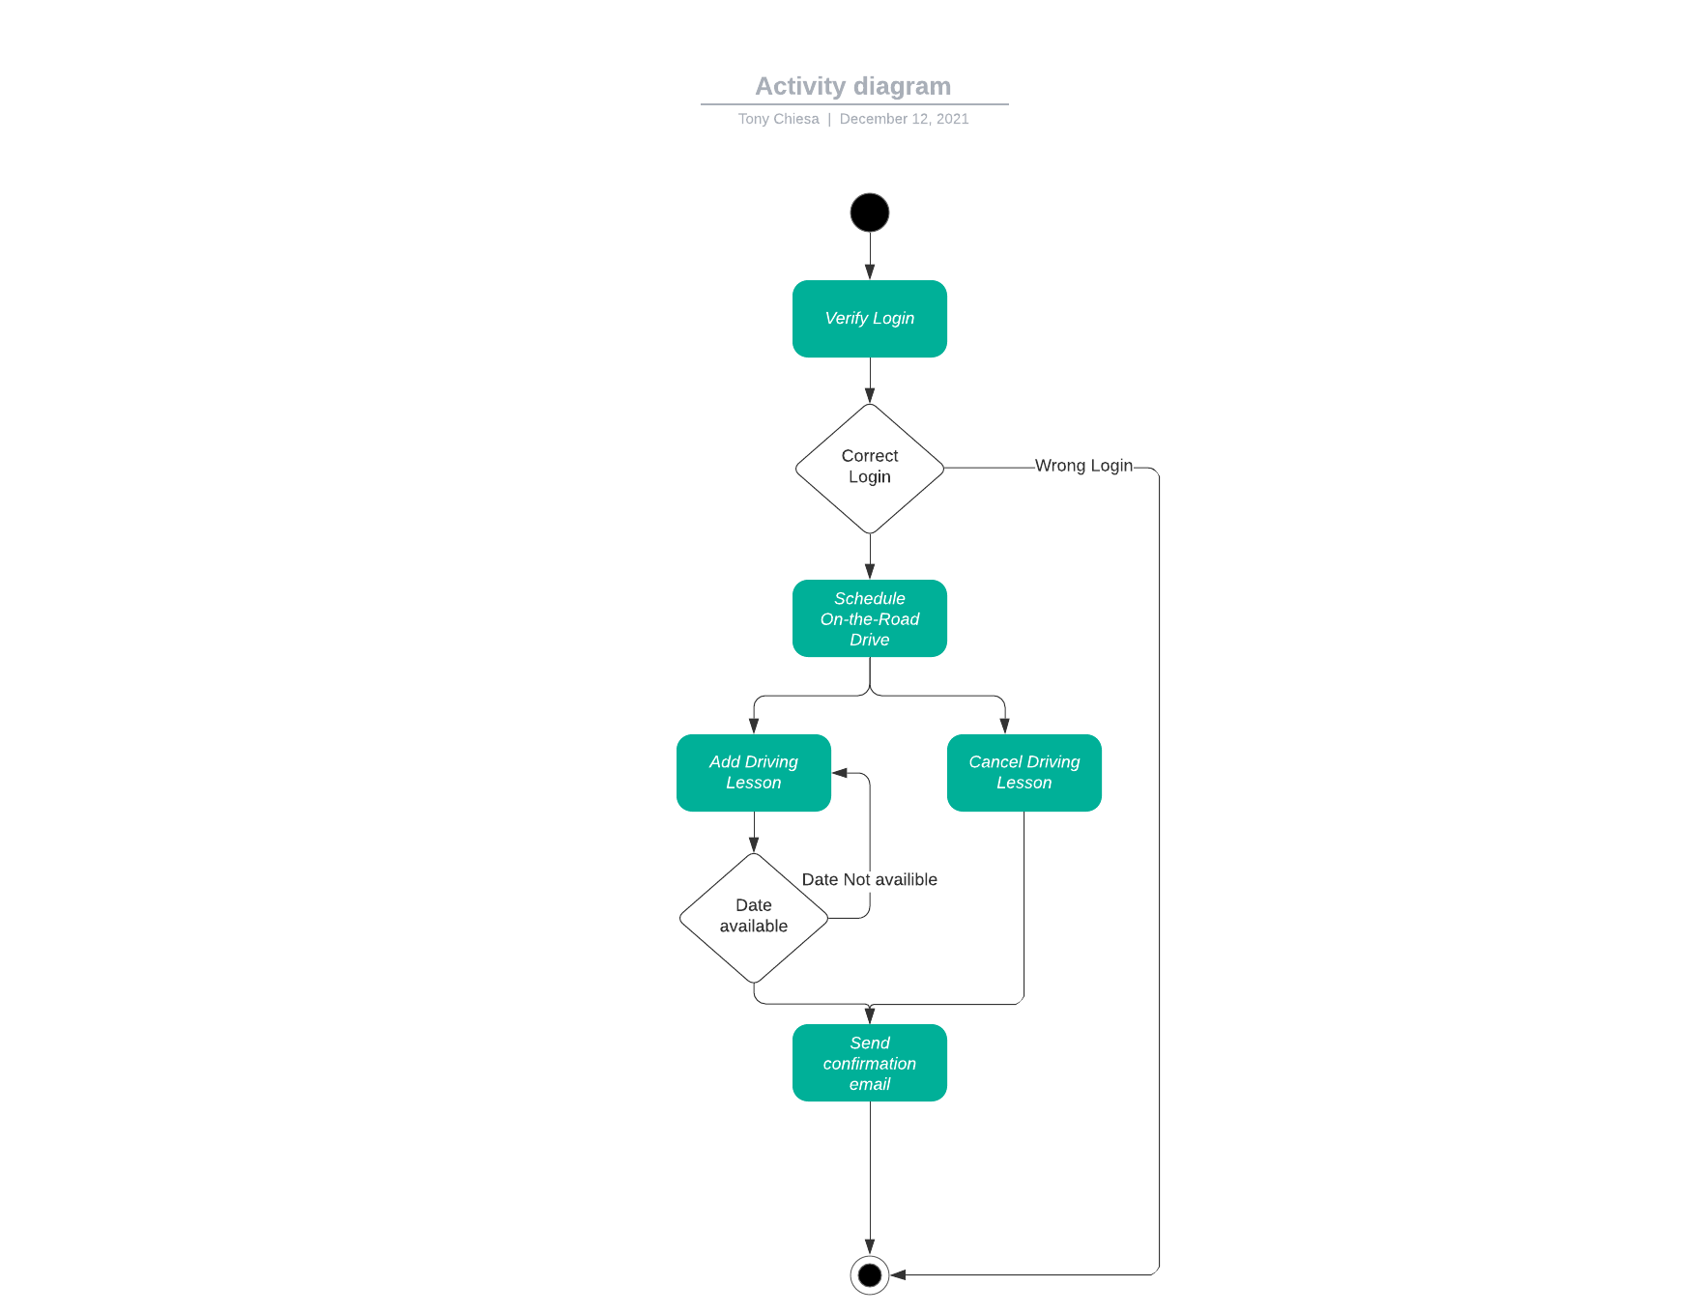

### UML Sequence Diagram

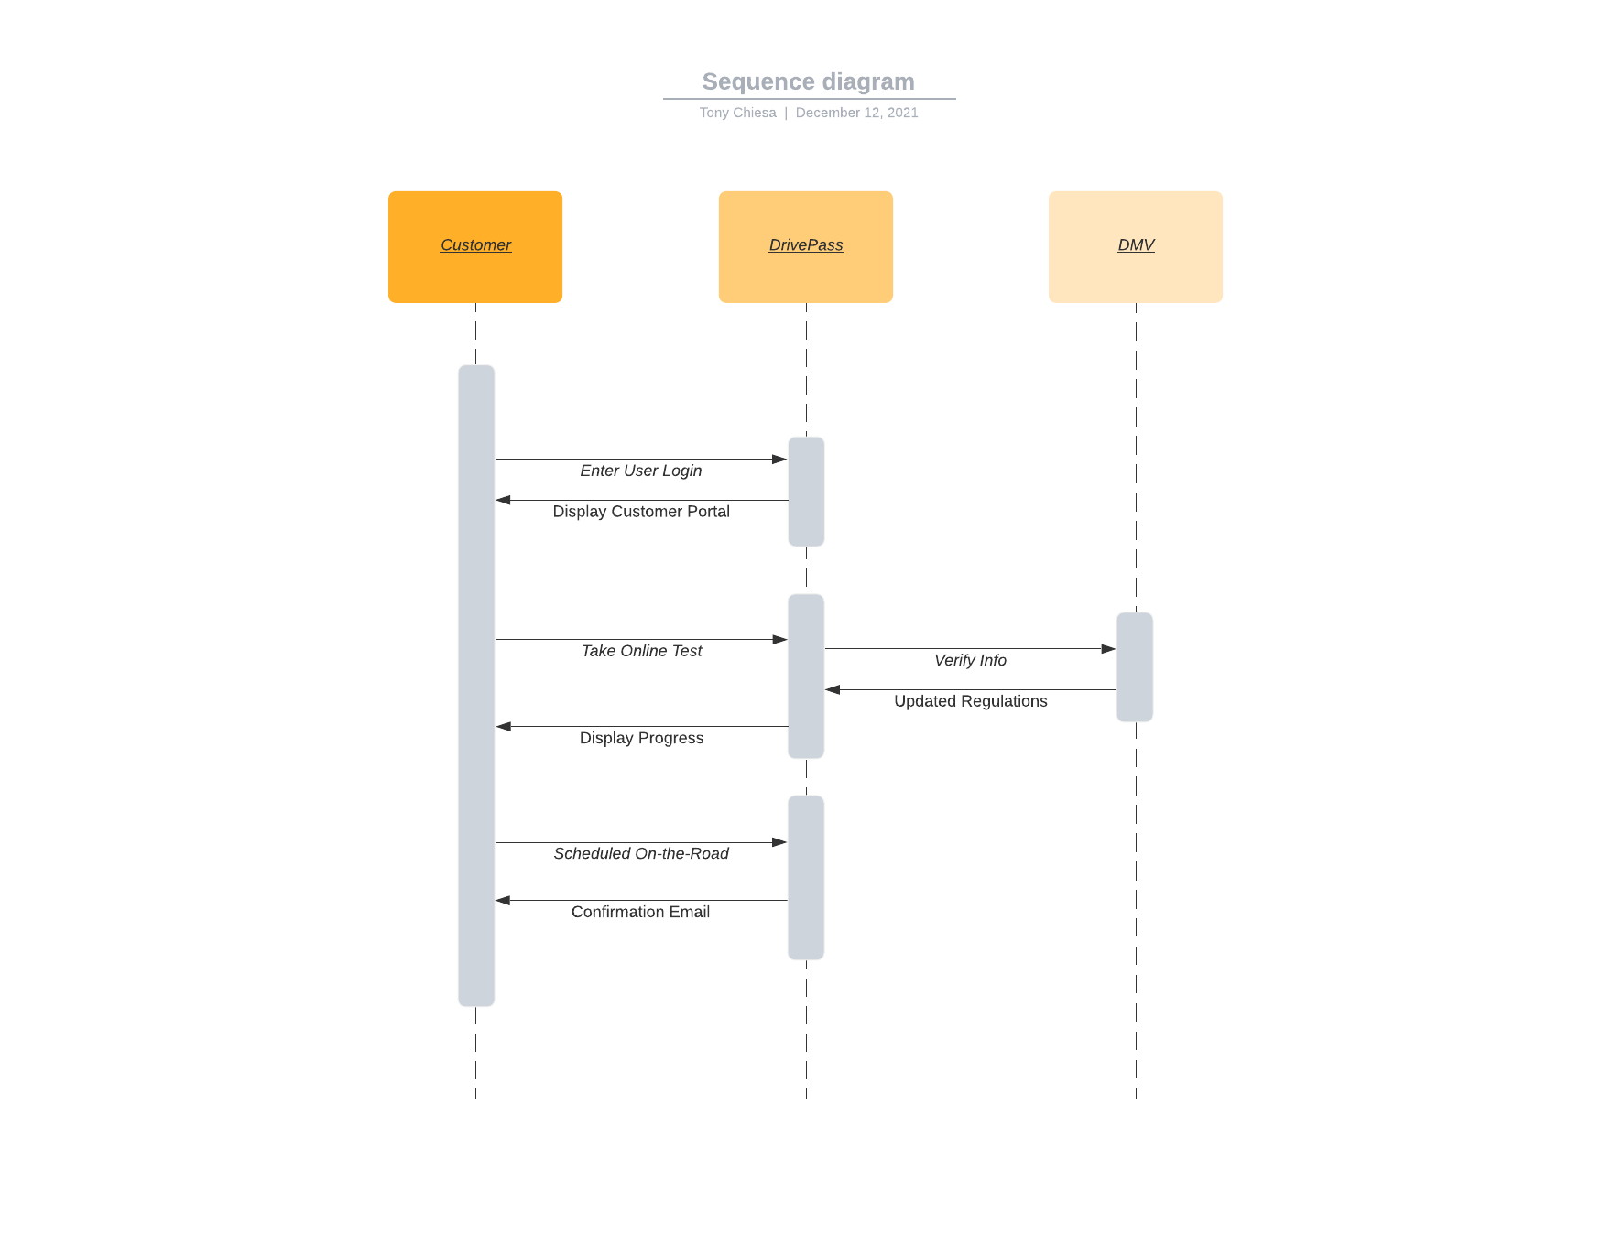

### UML Class Diagram

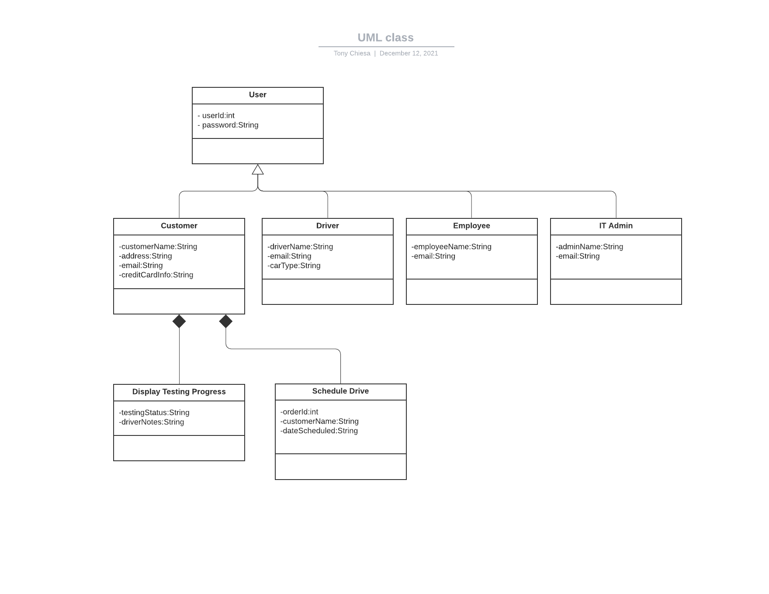

## Technical Requirements

#### Based on the diagrams the system should run on a Windows server platform, utilizing Internet Information Services (IIS). Additional services for backups and higher-level security will be required so that DrivePass can focus on the business operations instead of the technical side. This leads into how data should be stored; the backend of the system requires a relational database. This will ensure that the data is organized correctly with pre-defined relationships.